Thomas cluster process

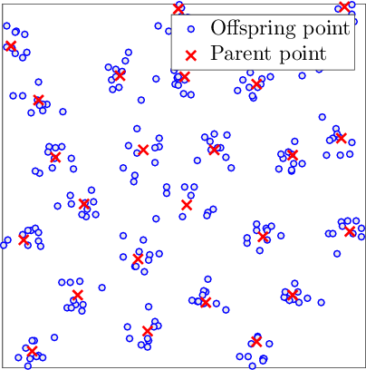

Model fitting

* Fits model to point pattern of mature seed trees (DMR == 6)
* Package: spatstat
* Function: kppm(X, trend, clusters)
  + X = point pattern dataset of seed trees (DMR == 6)
    - Mature tree DMR infection data from Shaw et al. (2005)
    - Window = owin(c(0, 400), c(0, 300))
      * Study area of 400 m x 300 m (12 ha)
  + Trend = ~1 (homogeneous)
  + Clusters = “Thomas”
  + Method = “mincon” (Fit by minimum contrast estimation; function default)

Model simulation

* Simulates point pattern of mature seed trees (DMR == 6)
* Package: spatstat
* Function: rThomas(kappa, scale, mu, win)
  + Kappa, scale, mu inputs taken from fitted Thomas cluster process model
    - Kappa: Intensity at which “parent” points are generated using uniform Poisson point process
    - Scale (aka sigma): Standard deviation of a point from its “parent” / cluster center
    - Mu: Mean number of “offspring” points per cluster
  + Win = owin object of mature tree edge polygon

Ordinal logistic regression

Model fitting

* Package: MASS
* Function: polr(formula, data)
  + Formula = DMR of non-seed trees (DMR > 6) ~ Distance to nearest seed tree (DMR == 6)
    - Assume that DM infection spreads from trees at DMR == 6
  + Data = Mature tree DMR infection data from Shaw et al. (2005)
    - 200+ years age class, old-growth Douglas-fir/western hemlock
  + Method = logistic (function default)

Model prediction

* Package: stats
* Function: predict(), type = “p”
  + Estimates the probability of infection at each DMR level (0-5) given its distance to the nearest seed tree (DMR == 6)
  + Using the estimated probabilities at each level, a weighted dice roll (Package: Rdice, function: dice.roll) is used to determine the DMR
    - Outcome will be different every model run

Output example

